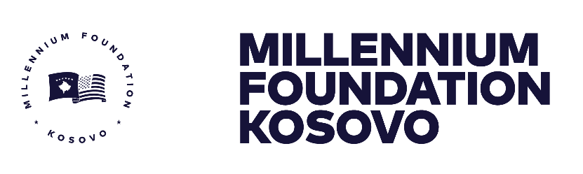

GENERAL PROCUREMENT NOTICE (GPN)
Government of the Republic of Kosovo
Millennium Foundation of Kosovo (MFK)
The Government of the Kosovo has received grant funding of USD$49 million (Forty-Nine Million United States Dollars) from the Millennium Challenge Corporation (MCC) of the United States Government to enable the Government of the Republic of Kosovo to implement this program and achieve the objectives of the MCC Grant Threshold agreement, and it intends to apply parts of the proceeds of the funds to payments for contracts for goods, works and services.
MCC’s funding is appropriated by the U.S. Congress and obligated to the compact up-front, with no incremental or partial funding. When a contract is signed with an MFK, money is already available to the MFK and, for most contracts, invoices are paid directly to Contractors/Consultants/Suppliers by the US Treasury.
The procurement program for this period will include the following:
Procurements for period February 2021 – December 2021
Procurement of Goods
In the Reliable Energy Landscape Project including:

DHM - Metering system supply & installing
Procurement of Works
In the Reliable Energy Landscape Project including:

Household Efficiency Retrofits (HER) Intervention Package - EE materials and products
AER -Apartment Building Efficiency Retrofits Sub-activity Works
Procurement of Services
In the Reliable Energy Landscape Project, Transparent Governance Project and Administration sector, including:

Software, Hardware, and TA in Communications & Outreach for the Public Access to Judicial Information Activity (Case Management Information System “CMIS”)
Consultancy (Stakeholders workshops for Judicial Dig Data Challenge)
Procurement of Consultant Services IPP and Energy Efficiency Project Accelerator and Pipeline Development Consultant: Demand-Side Training, Firm-Level Engagement, and Marketing Strategy
Communication and Outreach for Judicial Data Challenge
Event Management for CMIS workshops and promotional activities
Consultants - Jury for Open Data Challenge
Dig Data Air Quality Awards Ceremony & Promotion and Events for the Energy Dig Data
Judicial Dig Data Challenge Consultant
Consultants - Jury for Energy Open Data Challenge
Programmatic Communications
Outreach activities and the launch event for the Internship Program
Data Quality Review for Reliable Energy Landscape Project and Transparent Governance Project
Contracts for goods, works and services financed under the program will be implemented according to the principles, rules and procedures set out in the MCC Program Procurement Guidelines, which can be found at the MFK website.
The procurement is open to all bidders from eligible source countries as defined in the MCC Program Procurement Guidelines.
Specific procurement notices for contracts to be tendered under the competitive bidding procedures and for consultant contracts will be announced, as they become available, on the MFK website: https://millenniumkosovo.org/ , United Nations Development Business (UNDB): http://www.devbusiness.com/, Development Gateway Market (dgMarket): http://www.dgmarket.com/, in local newspapers, and other media outlets as appropriate.
Interested eligible contractors and consultants who wish to be included on the mailing list to receive a notice of advertisements should subscribe on the MFK website under the link: https://millenniumkosovo.org/subscribe/, type your email and select under the list Procurement, or those requiring additional information, should contact:
Procurement manager: | Arton Çitaku – MFK Procurement Manager
c/o: | Millennium Foundation of Kosovo
Address: | Str. “Migjeni” no. 21 (ex-Bank of Ljubljana, floor IX),  Postal Code:10000 Prishtina, Kosovo
Telephone: | + 383 38 752 110
Email: | procurement@millenniumkosovo.org

