Request For Quotation
Reference Number: Shop #2021/030
07 December 2021

Procurement Title: Asbestos sampling at skyscrapers – Ulpiana
Dear Sir/Madam

- The Millennium Foundation Kosovo that manages the Threshold Agreement with funding from the Millennium Challenge Corporation, intends to procure the goods for which detailed specifications are provided for below:

- You are invited to submit your price quotation in a pro forma invoice format for each article should have a with for the supply of the items listed in Annex 1 of this RFQ and attached the Business registration form with details.

Currency | Euro
Delivery expected | Starting immediately and services should be delivered not later than 10 days after the Purchase Order.
Quotation Validity | 90 days
Quotations submitted via: | Only in email: procurement@millenniumkosovo.org
Deadline | Quotation in email must be delivered to the address below no later than 13.00 Kosovo Time of 13 December 2021.

- Your quotation in the required format should be addressed to:

Millennium Foundation Kosovo
Address: Str. “Migjeni” no. 21 (ex-Bank of Ljubljana Building, 9th floor)
Prishtina 10000, Kosovo
procurement@millenniumkosovo.org

Yours sincerely,
Arton Çitaku
Procurement Manager
Millennium Foundation of Kosovo

PRODUCT SPECIFICATIONS AND PRICE SCHEDULE
Services to be supplied with detailed description required by Millennium Foundation Kosovo, are listed in the table below:

ART. NO. | DESCRIPTION | QTY. | PRICE PER UNIT EURO | TOTAL PRICE IN EURO
1 | Asbestos sampling at skyscrapers – Ulpiana as per Terms of reference attached in annex 1 | 1
Total Price in euro excluding the taxes applicable in Kosovo
The grant is free from taxes including value added tax in Kosovo, please see for more details in Grant agreement in the link: https://assets.mcc.gov/content/uploads/tpaa-kosovo.pdf

Economic Operator Identification
Company Name
Full Address
Represented by:
Name & Surname
Position
Signature
Date
Stamp

Annex 1: “Asbestos sampling at skyscrapers – Ulpiana”
(Terms of References)
Introduction
Millennium Foundation Kosovo (MFK) is the Implementing Entity of the Threshold Program Agreement between the United States of America, acting through the Millennium Challenge Corporation (MCC), and the Government of Kosovo. The Threshold Program addresses two key constraints to Kosovo’s economic growth: an unreliable supply of electricity; and real and perceived weakness in the rule of law, government accountability, and transparency.

The “Subsidies for Energy Efficiency in Kosovo” (SEEK) project under the RELP, consists of three (3) intervention packages (IP):
a) Household Efficiency Retrofits (HER)
b) Apartment Building Efficiency Retrofits (AER), and
c) Women Energy Entrepreneur (WEE)
Within the AER Intervention Package, 26 subprojects (Multi Apartment Buildings - MAB) have been selected for renovation works in 6 municipalities in Kosovo.
In Pristina Municipality, five (5) MABs have been selected, the residential towers in Ulpiana neighborhood, or known to the general public as the "Soliterat".
These buildings were built around 1963. The project of "Ulpiana" neighborhood with skyscrapers was part of the "Program for urban settlement of three residential units and the regional center of the new part of the city" (1962). Up to the present time, there has not been any initiative in regards to the renovation of these buildings.
The Energy Audit of skyscrapers and the engineering-architectural project was carried out by the World Bank-supported project "Establishment of Homeowners’ Associations in Residential Buildings in Condominium”, which was implemented by the Ministry of Economy and Environment, respectively the Kosovo Energy Efficiency Agency. The project was submitted to the Municipality of Pristina and it contains: Architecture (the existing situation and the interventions foreseen by the project); Machinery; Electricity; Bill of quantities; and Energy Audit.
Due to the age of these buildings, it has been assumed that the current façade might contain asbestos hazardous substance. Consequently, it is required to confirm this supposition by testing a façade sample and proposing a managing plan to be implemented during the refurbishment works, in case the asbestos presence is confirmed by an authorized laboratory.

Positions of the buildings within the city, characteristics and designation
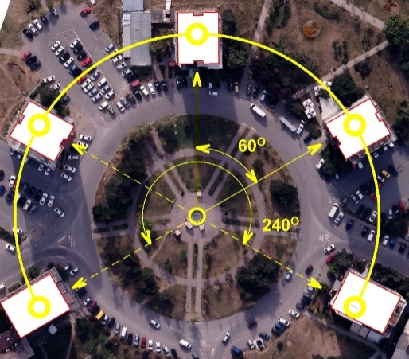
The skyscrapers are located in the Ulpiana neighborhood in the southeast of the city of Pristina, respectively in the southeast of the central area of the city on "Isa Boletini" street. Within the neighborhood, the skyscrapers extend to the eastern edge along the perimeter of the neighborhood. In terms of spatial organization, they are located concentrically towards the center of the imaginary circle with a 240 º apertures, the so-called "Fountain roundabout". Each skyscraper is moved every 60º.
Figure 1 - Ulpiana neighborhood and skyscrapers in relation to the city

1

2
3
4
5
Figure 3 - Designation of skyscrapers
Figure 2 - Spatial distribution

Three out of five skyscrapers (1,2 and 3) consist of G+12+PH floors, while lower story skyscrapers (4 and 5) comprise of G+8+PH floors and do not fall into the category of tall buildings. However, since they have a similar architectural treatment and are part of an urban ensemble, all five buildings are referred to as skyscrapers. Skyscrapers 4 and 5 are located at the edges of the imaginary circle of 240 degrees, while skyscrapers 1, 2 and 3 are arranged in the middle. Each floor has four residential units.
Figure 1 - Ulpiana neighborhood and skyscrapers in relation to the city
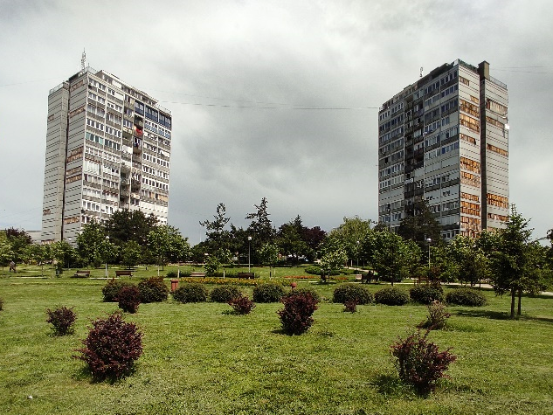
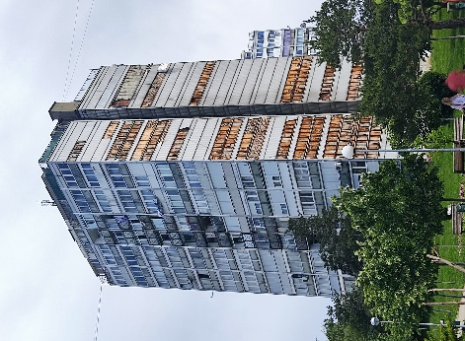
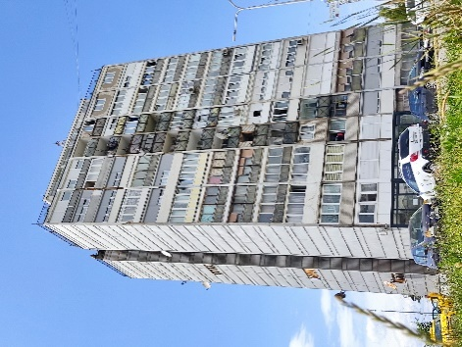

The assignment
The assignment addressed in this ToR demands services of an internationally accredited assessor to cover the following main tasks:
Task 1: inspect the building envelope of the selected 5 skyscrapers,
Task 2: organize and conduct testing of representative samples, and
Task 3: determine if any Asbestos of Asbestos Containing Materials are present in the selected buildings, and
Task 4: propose a management plan to be used by the contractor (construction company) charged with the implementation of the refurbishment of skyscrapers.
Completion of the 4 tasks asks for the following four (4) main groups of activities:

Activity 1: Desktop study and preparation of an Inspection Plan
This activity includes a desktop study of existing plans/drawings. The aims of the study are to:
- Study the plans/drawings and other information provided by MFK and the Pristina municipality to familiarize and identify the extent of site work required during the inspection.
- Identify international standards that are applicable for the on-site inspection, testing and reporting.
- Identify materials and other resources required for sampling and wrapping of materials for testing.
- Identify occupational health and safety issues in the implementation of the assignment and propose mitigation measures.
Activity 2: On-site inspection and sampling to assess the presence of Asbestos in the five skyscrapers’ Building Envelopes.
A licensed Assessor with appropriate qualifications, experience and accreditation is expected to carry out a comprehensive visual inspection on-site and sampling to assess the presence of Asbestos in the five (5) buildings that are subject of refurbishment.
Based on the inspection, if there are areas suspected to contain Asbestos, the Assessor shall take samples from such areas for laboratory testing. Sampling methodology and sizes of samples shall be decided by the Assessor, based on the Assessor’s professional judgement and international best practices, complying with applicable international standards.
When taking samples, the Assessor shall carry out the activity of sampling ensuring utmost safety of him/herself, other staff, occupants of the building and general practice. During sampling, at no time, any individual shall be exposed to any risk of contamination with possible Asbestos. Sampling shall be done as per industry best practices, complying with applicable international standards.
Samples thus obtained shall be wrapped with appropriate material immediately after removal from the location to avoid any possible contamination. Wrapping shall be done using appropriate materials as per industry best practices complying with the requirements of applicable international standards. Samples shall be stored in a safe place after removal and wrapping, until they are sent to the laboratory for testing. For the purpose of the bidder’s proposal, up to ten (10) samples shall be allowed. If the number of samples actually taken are different from this number, the Assessor must request approval from MFK for the number of samples proposed to be taken, prior to the commencement of sampling.
Upon completion of the inspection and sampling, the samples taken shall be sent to an accredited laboratory for testing.
All arrangements related to transportation including freight shall be the responsibility of the Assessor. Cost of transportation including freight, insurances and all other costs shall be included in the Bidder’s offer.
Activity 3: Laboratory testing of samples at an accredited laboratory
The samples obtained during the on-site inspections shall be tested in a certified and accredited laboratory to test the presence of Asbestos. In the technical proposal as a part of the tender submission, the Assessor shall nominate a laboratory where the testing will be conducted.
Copies of certificates of accreditation of the proposed laboratory must be attached to the Technical Proposal to be submitted as a part of the tender submission. Laboratory testing shall be conducted in compliance with industry best practices and applicable international standards. The bidder must list the applicable standards for laboratory testing in the Technical Proposal. Testing must be conducted by competent personnel of the proposed laboratory with adequate experience and necessary skills in testing for Asbestos and other hazardous building materials as per international standards.

Activity 4: Prepare and submit a comprehensive report on the assessment
Upon completion of the on-site inspection and laboratory testing, the Assessor shall prepare a draft Final Report and submit it to MFK for review. The Final Report shall consist of the following as a minimum:
- Executive summary
- Project team including their qualifications, accreditations, certifications and experience
- Policy, Legal and Regulatory Assessment including Standards adopted
- Methodology
- Inspection procedure and outcome of inspections
- Laboratory testing and results (attach certified test results as an Annex)
- Conclusion of inspections and laboratory tests
- Recommended method of removal of Asbestos (if the presence was confirmed). The method should be addressed in detail so that the information can be directly passed over to the Contractor for implementation.
- References
- Annexes
MFK will review the draft Final Report and provide comments within five (5) working days. Upon receiving comments from MFK, the Assessor shall finalize the report within five (5) working days and re-submit it to MFK for approval.
At all times during the execution of this assignment, the Assessor must adhere to strict occupational health and safety requirements. As a minimum, the Assessor must comply with the laws and regulations on occupational health in Kosovo at all times.
Outputs/Deliverables
The following are the expected outputs/deliverables from this assignment:
- Inspection Plan – to be submitted within two (2) days after signing the Contract.
- Draft Final Report – Within one (1) week from the date of signing of the Contract.
- Final Report – Within three (3) days after the received comment from MFK.
All reports must be prepared in English and submitted in an editable form (Word), and in a soft form only (no hard copies required).

